OT-One: Removing shipping bolts



Written by Opentrons

Updated this week

# This article is about the OT-One.

## **It's no-longer sold or actively supported by Opentrons, but we've kept this article here to help existing users. Please** [**see our OT-2 Support articles**](https://support.opentrons.com/) **for the most up to date information!**

## **Overview:**

To prevent damage during shipping, the axes of the OT-One S are secured with 6 locking bolts and 2 L brackets.

These need to be removed prior to powering on your robot. All of the hardware necessary to remove them has been provided within your accessory box.

[**Complete accessory List**](https://support.opentrons.com/hardware-questions/parts-and-accessory-list)

## **Materials:**

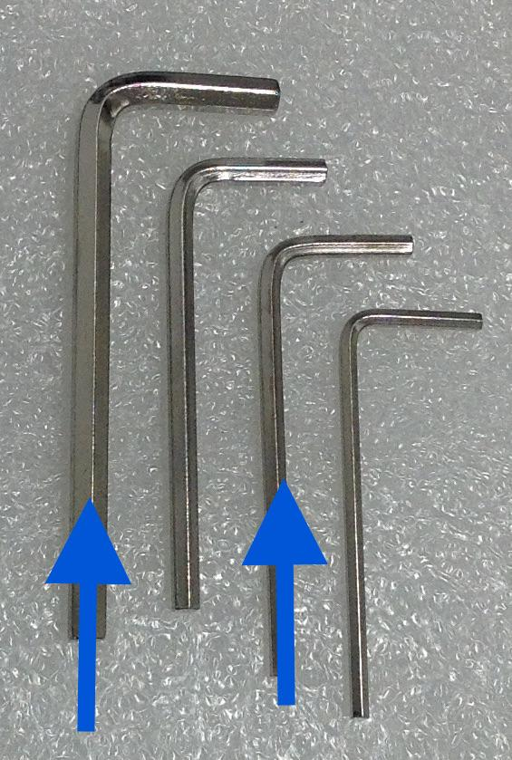

## **Procedure:**

Step 1: Y left locking bolts

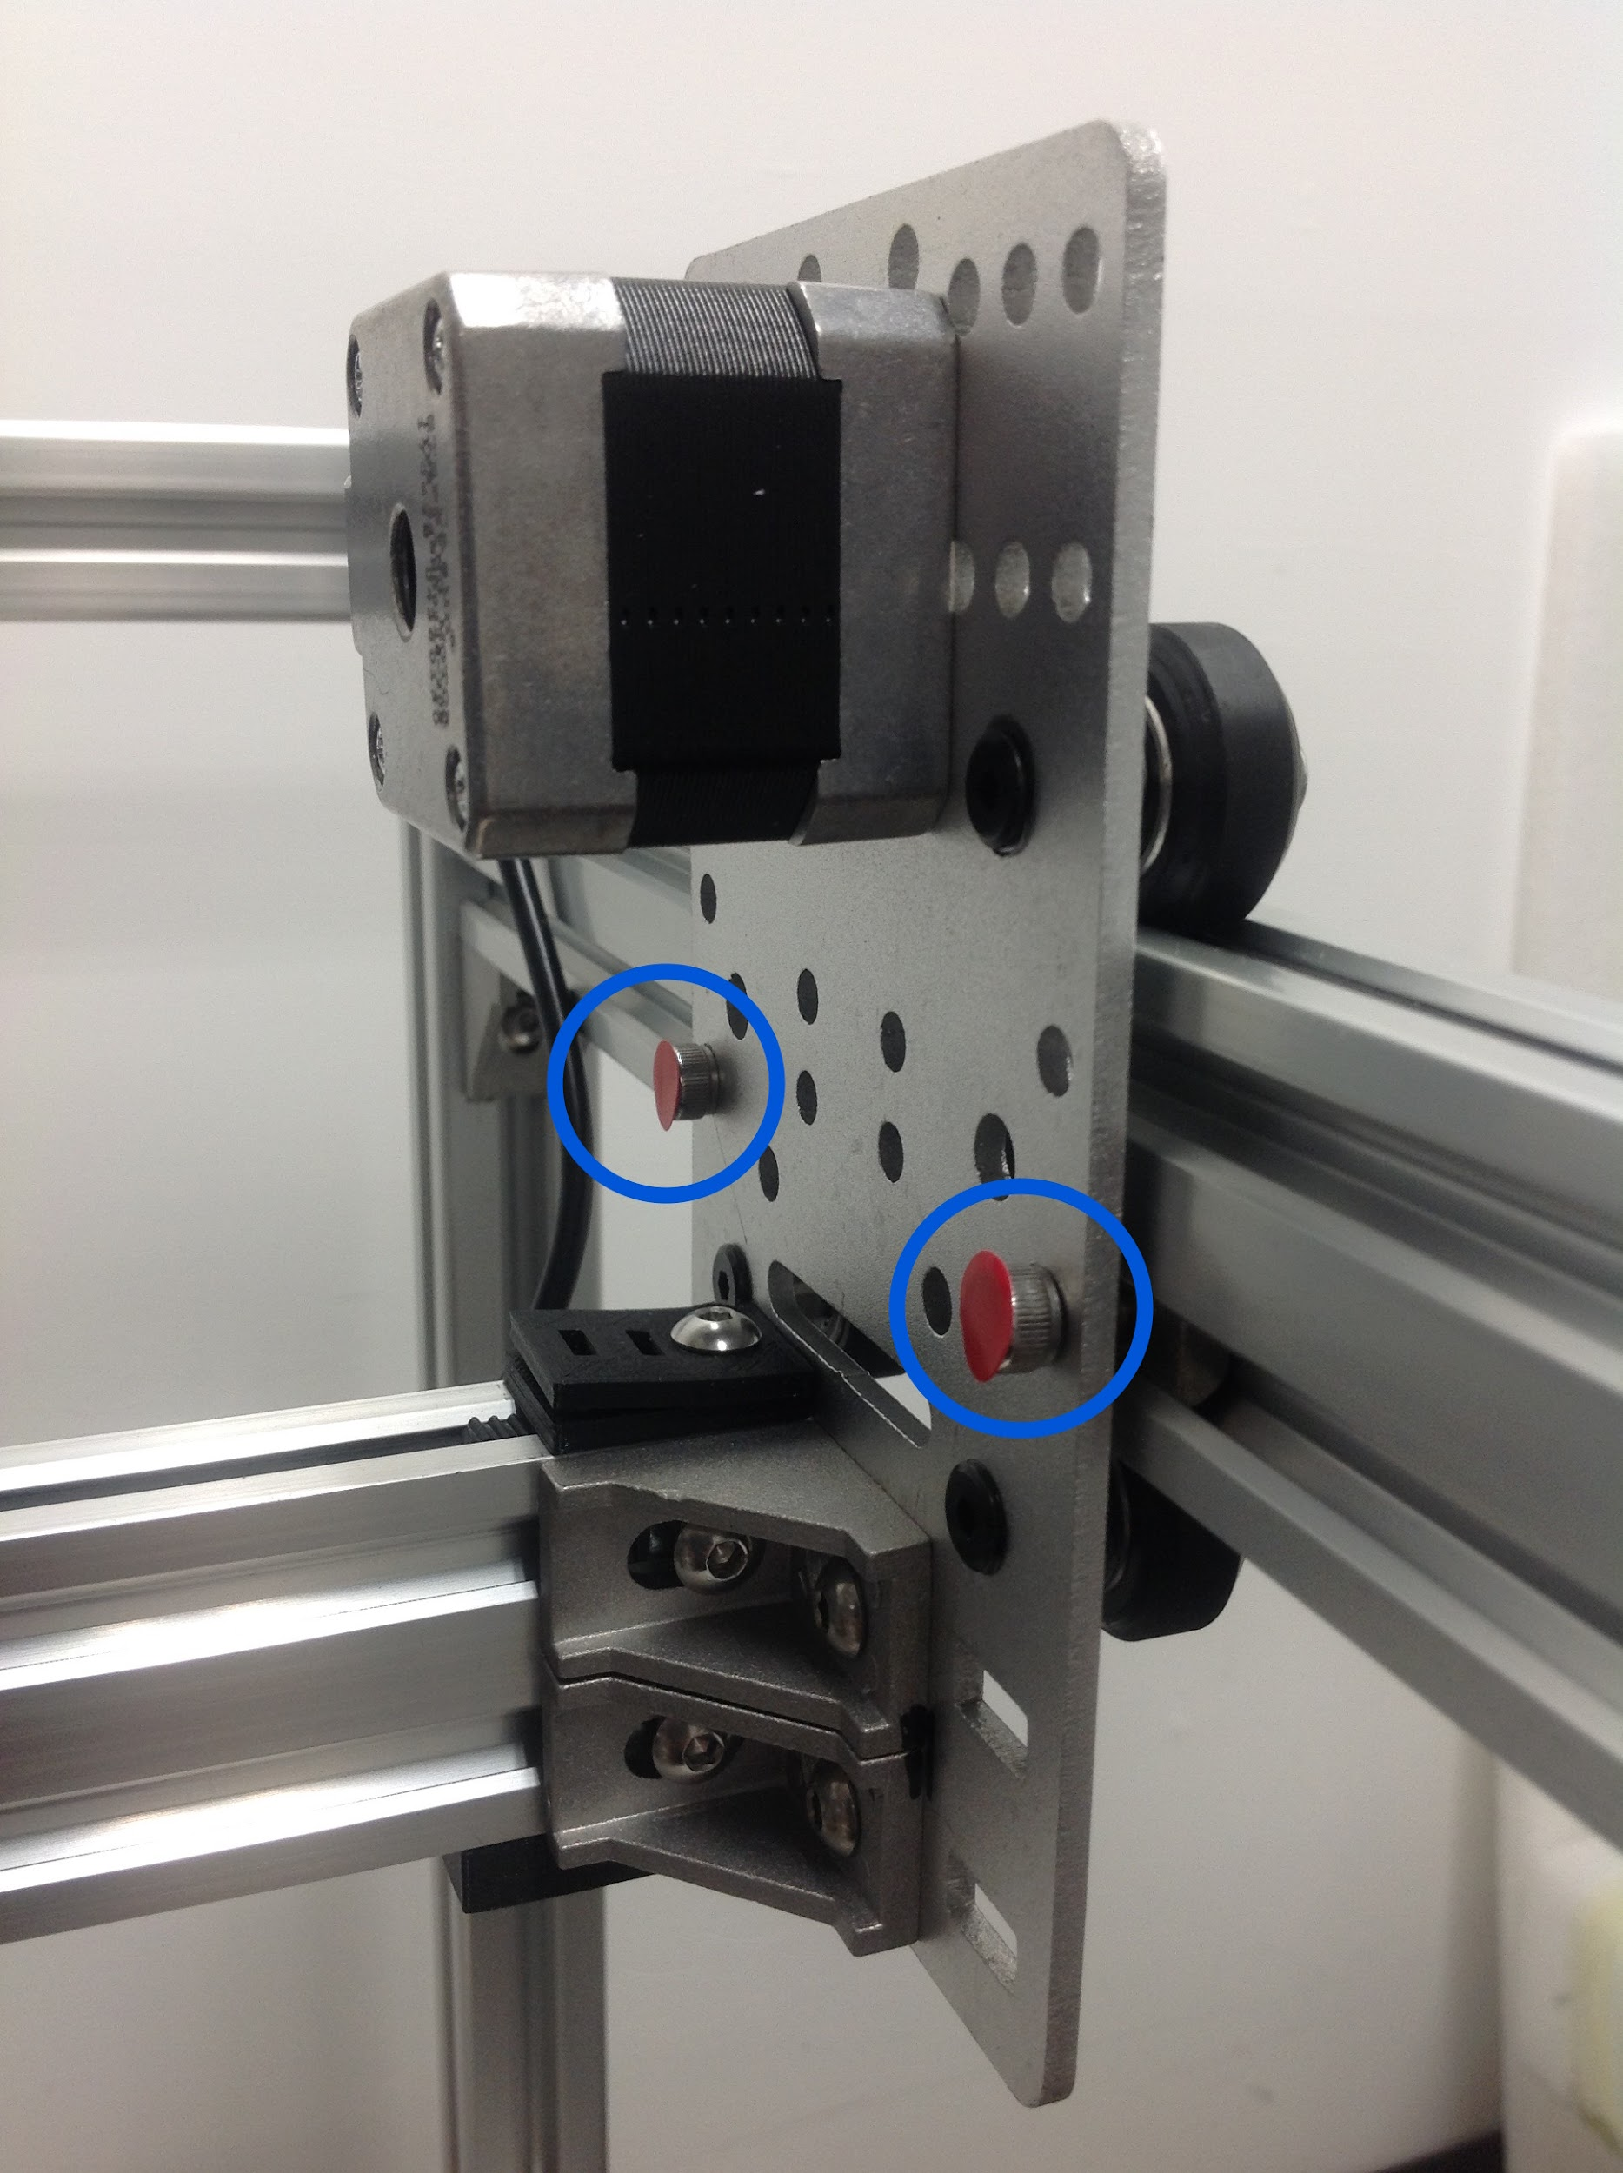

Y right locking bolts

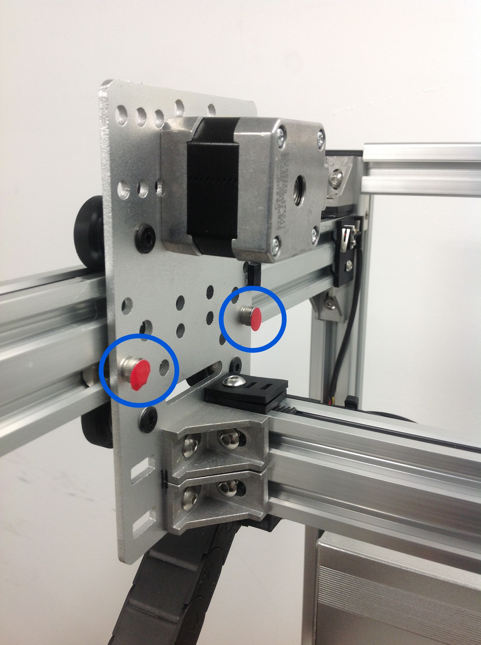

Use the largest allen key in your set to remove the bolts, you may leave the insert in the rail it will not affect the performance.

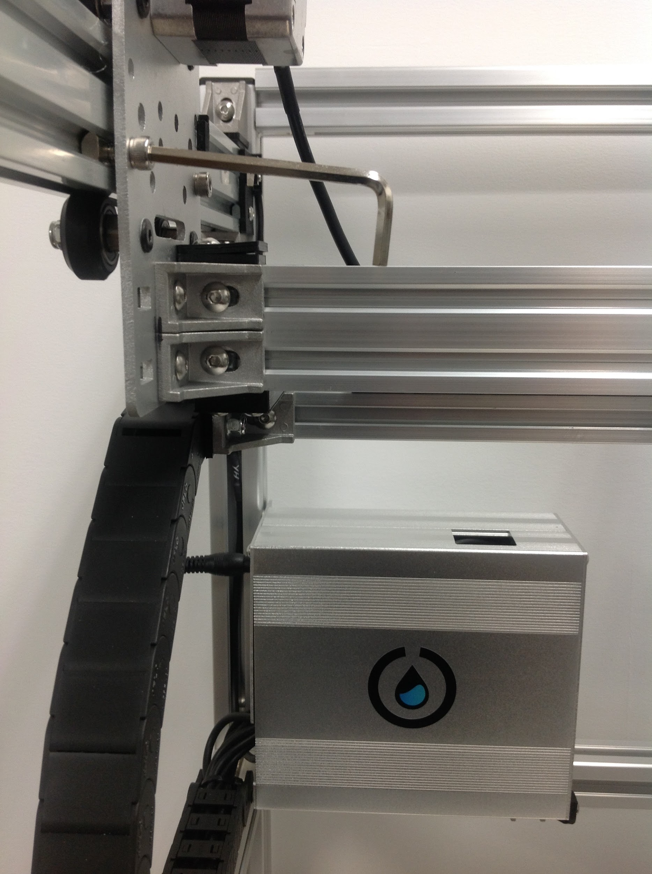

Step 2: OT-One S Hood will have the X axis locking bolts on the back of the robot by the cable track.

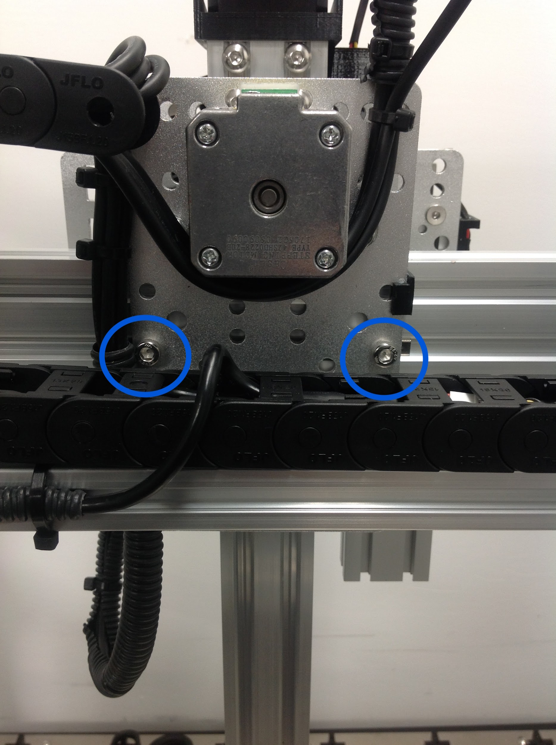

OT-One S Pro will have the locking bolts on the front, one behind the B motor and another

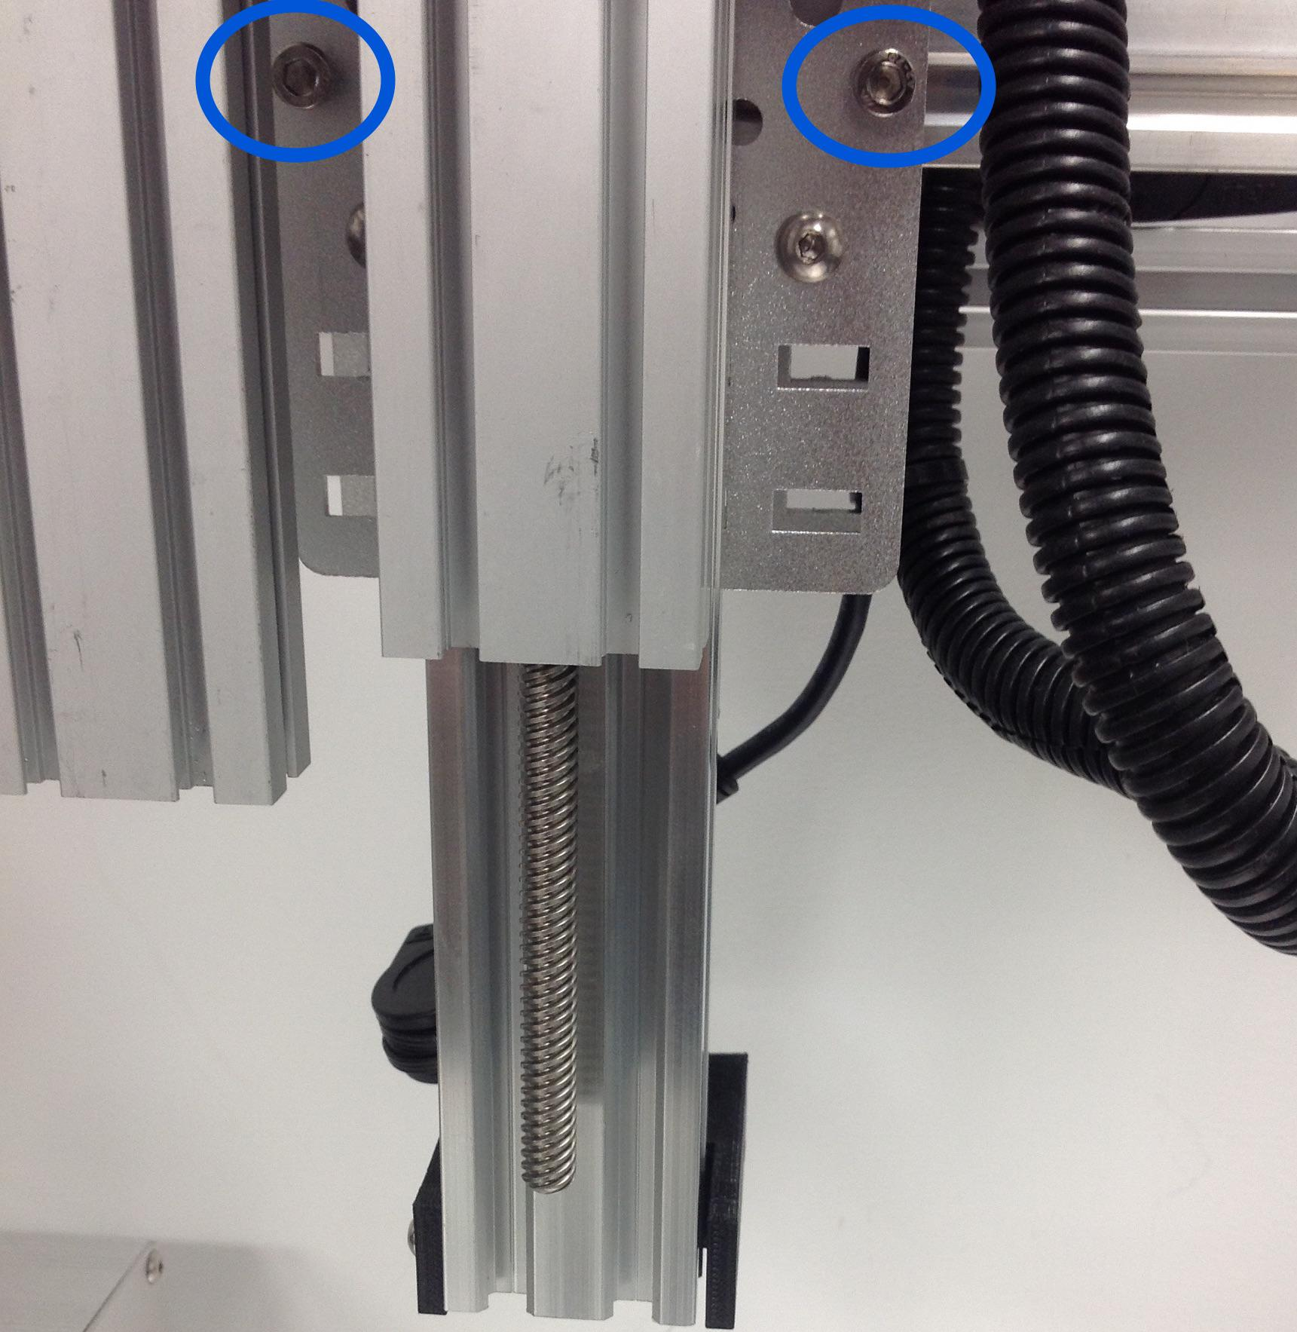

Step 3: Z axis locking L brackets

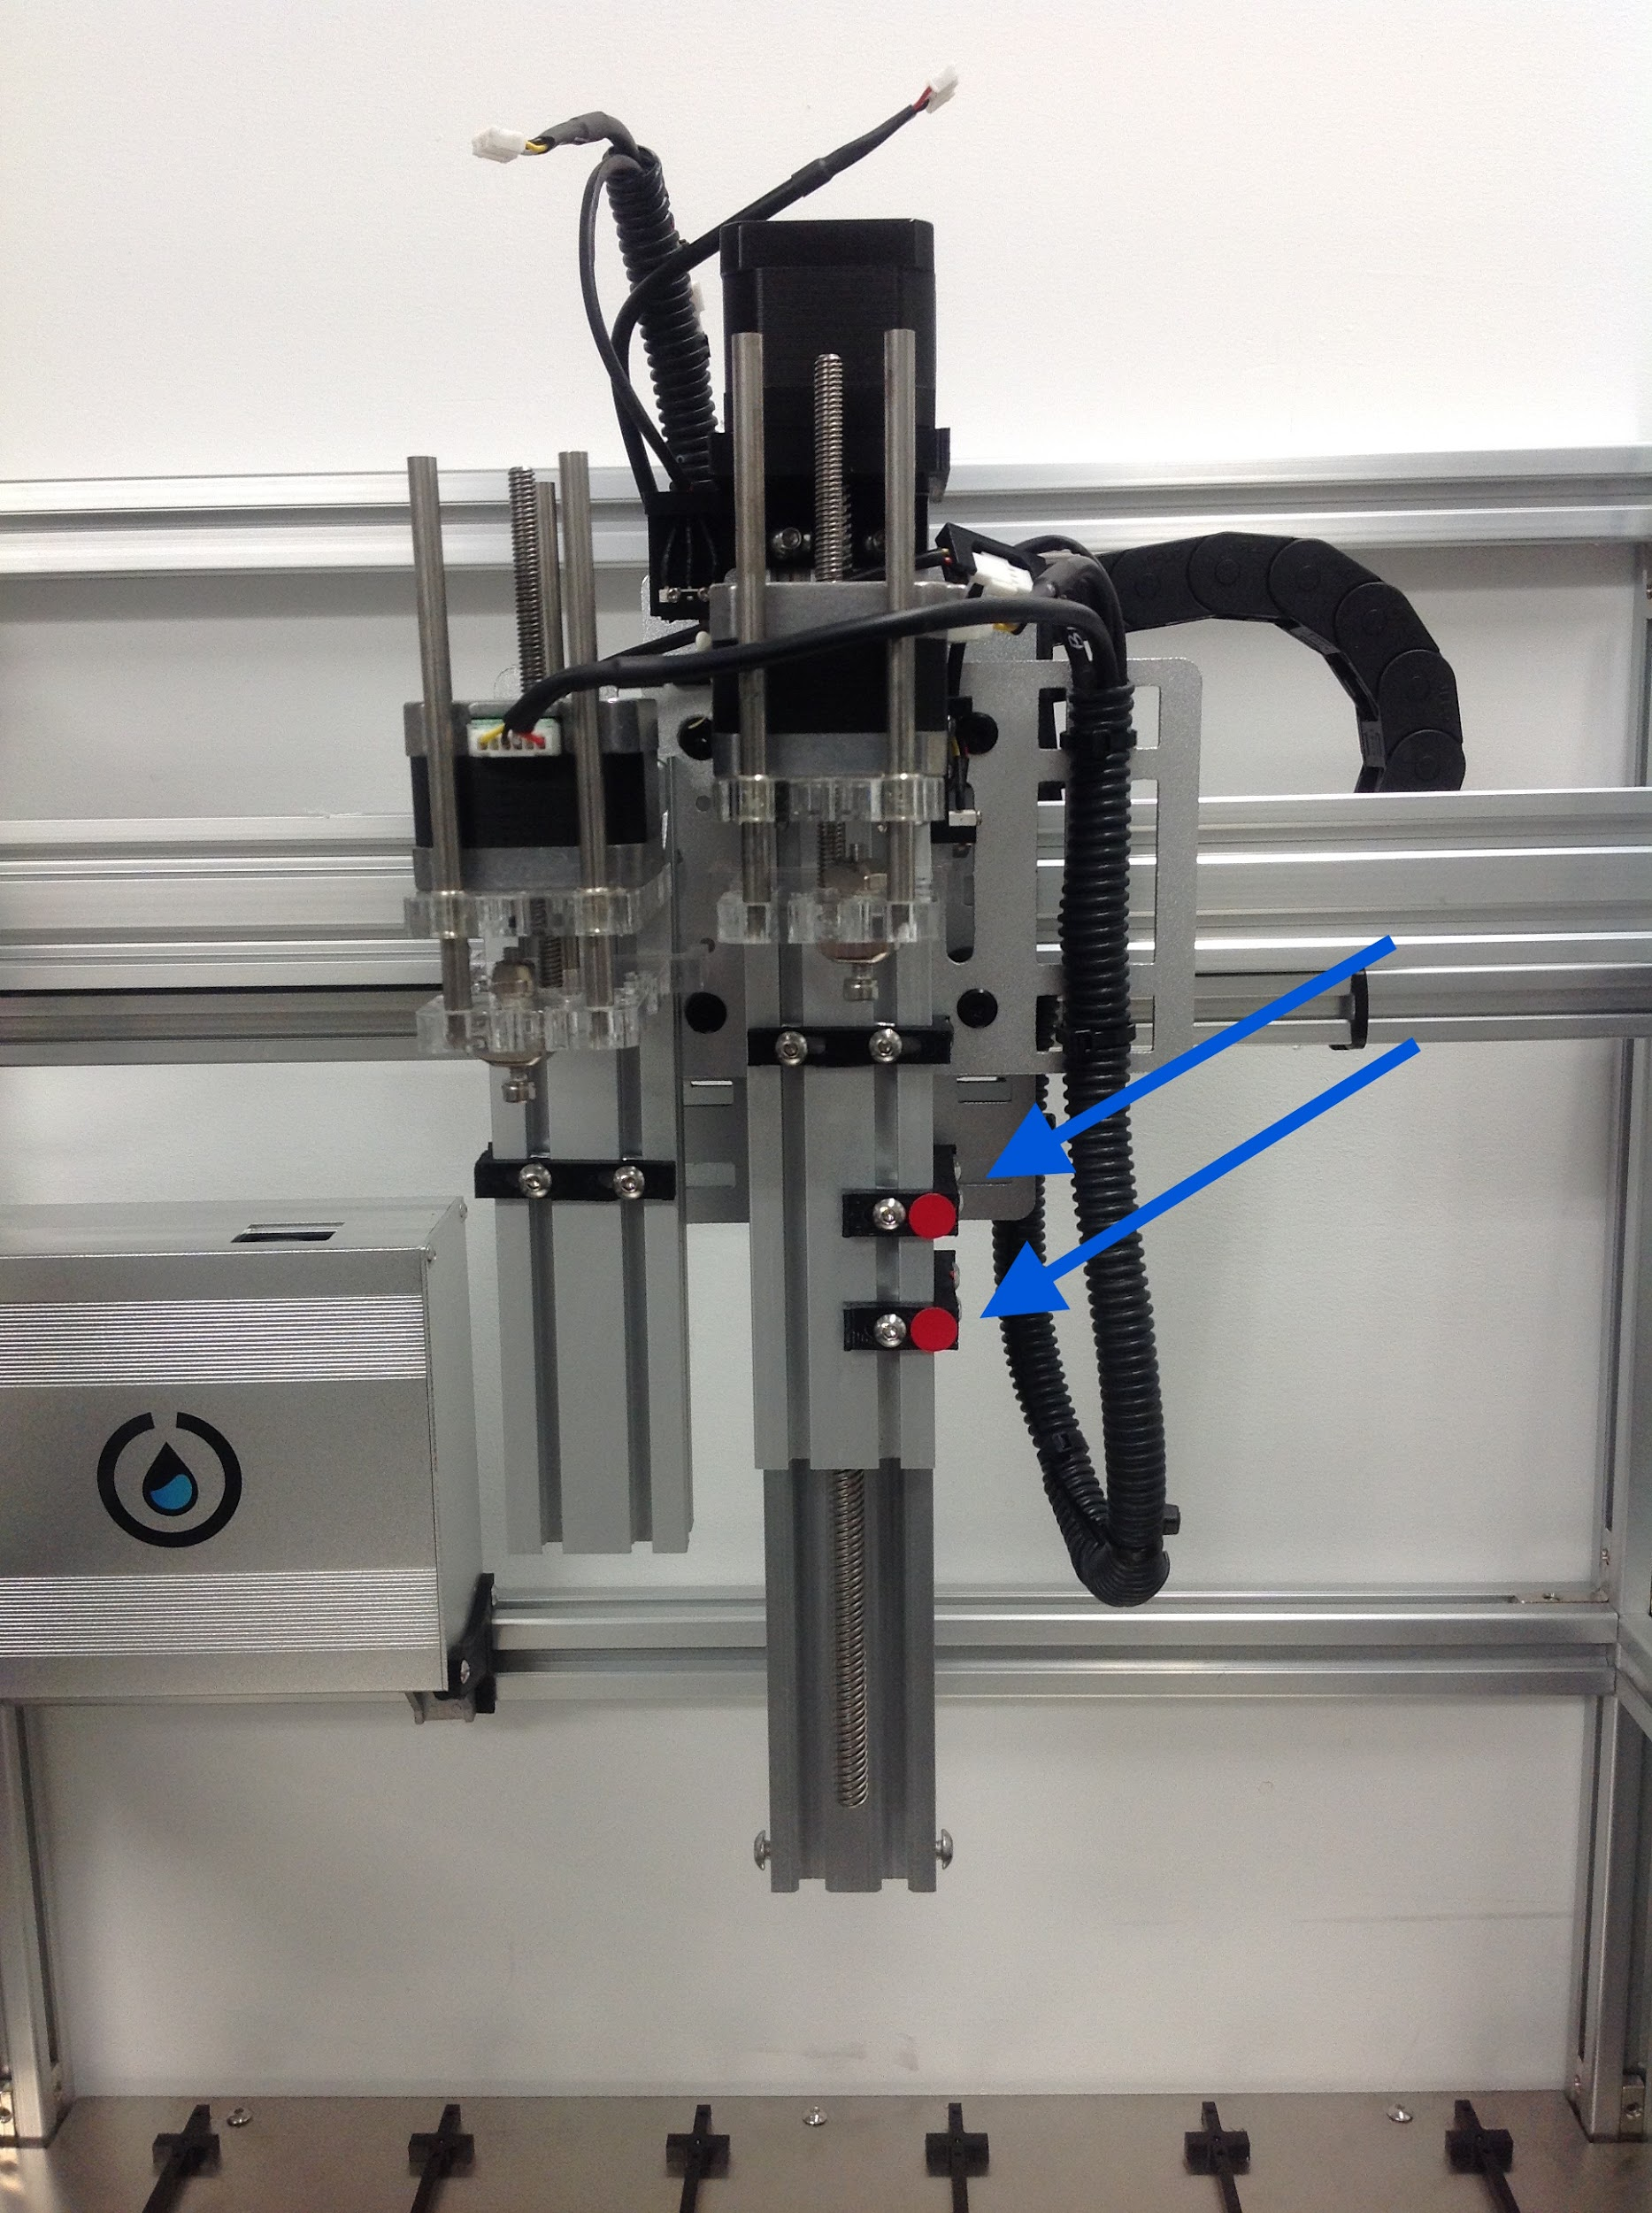

Use the 2nd smallest allen key in your set to loosed and slide off.

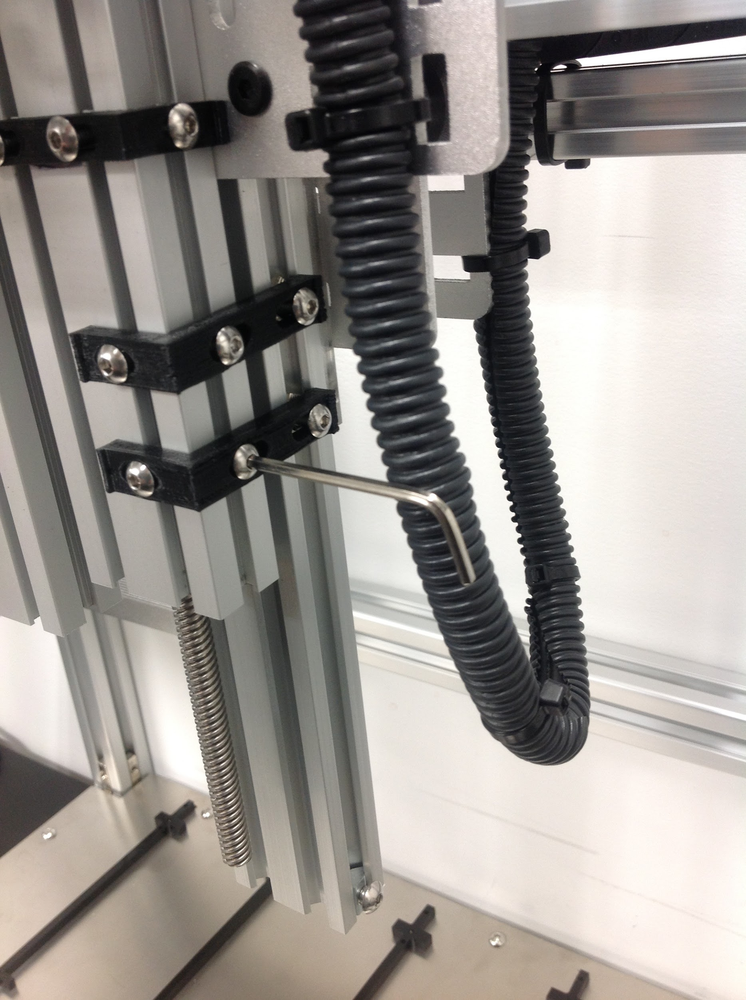

[**Next Article**](https://support.opentrons.com/getting-started/unboxing-your-robot/connecting-motors)

If you have any issues or further questions please contact us! support@opentrons.com